GUIDANCE ON COMPLETION OF SECTIONS 1 AND 3 OF THE IUCLID 5 DOSSIER:
IRON [EINECS number 231-096-4, CAS number 7439-89-6]

as Iron, Furnace [Pig iron, Direct Reduced Iron, Hot Briquetted Iron]

INTRODUCTION 2
1. GENERAL INFORMATION 3
1.1 IDENTIFICATION 3
1.2 COMPOSITION 6
1.3 IDENTIFIERS 10
1.4 ANALYTICAL INFORMATION 11
1.5 JOINT SUBMISSION 13
1.6 SPONSORS 14
1.8 RECIPIENTS 16
3. MANUFACTURE, USE AND EXPOSURE 17
3.1 TECHNOLOGICAL PROCESS 17
3.2 ESTIMATED QUANTITIES 22
3.3 SITES 23
3.4 INFORMATION ON MIXTURES 25
3.5 LIFE CYCLE DESCRIPTION 26
3.6 USES ADVISED AGAINST 27
3.7 Exposure Scenarios, exposure and risk assessment 28
3.7.1 Exposure scenarios and local assessment 28
3.7.2 Environmental assessment for aggregated sources 28
3.7.3 Generic exposure potential 29
3.8 BIOCIDAL INFORMATION 30
RECOMMENDATIONS CONCERNING SUBMISSION 30

INTRODUCTION
This document details the information submitted by the Lead Registrant for Iron [with respect to pig iron and HBI/DRI] and is intended as a guide to member registrants for completion of the necessary fields of sections 1 and 3 of their IUCLID 5.4 dossiers for Iron.

Note however that the text of REACH Regulation is the only authentic legal reference and the information contained in this document does not constitute legal advice. It is therefore recommended that member registrants should read all relevant ECHA Guidance documents, for example Practical Guide 9: How to do a registration as a member of a joint submission (August 2010).

Member registrants should make themselves aware of all new updates of the IUCLID software and its plug-ins (IUCLID installation kit).

This document contains two types of information:

- that which will be common to all dossiers which are part of the Joint Submission for Iron - the cells for which in this document are highlighted in orange;
- that which is particular to your company - the cells for which in this document are highlighted in blue;
- Cells highlighted in grey relate to headings only and have no content.
In order to input data to fields, please click on the EDIT button or select Control-E.
Do not forget to save data entered by clicking on the save button.

Do not forget to check your substance and dossier files with the IUCLID 5.4 Technical Completeness Check (TCC) plug-in tool [don’t forget to update this plug-in].

If confidentiality is required, the registration fee will be more expensive and a justification has to be provided! Note that ECHA has issued in July 2012 a guidance document on confidentiality claims - this can be downloaded from the ECHA website - Data submission manuals or from the Library page of the Iron Platform website.

A fee calculator plug-in is available. This plug-in assists Legal Entities in calculating fees associated to REACH or CLP dossiers.

Information on the creation of a new substance is available on the Iron Platform website in the SLIDES FROM IUCLID AND REACH-IT WEBINAR 08/07/2010 [slides 14-20]. Member registrants will have to import all IUCLID files [reference substances and the file containing the uses] provided by the Iron Platform before creating their substance files. A guidance document “How to import an i5z file into IUCLID 5.2” is available on the Iron Platform website [also applicable for IUCLID version 5.4].

An IUCLID 5.4 dissemination plug-in is available. This allows a registrant to preview or simulate the information from its registration dossier that ECHA will make available via the internet. You can find more information on disseminated data in the ECHA Data Submission Manual, Part 15 - Dissemination (July 2012) and its Technical annex for IUCLID section 1, 2, 3 (July 2012) - these documents are also avaiulable on the Library page of the Iron Platform website.

Note: The new version of IUCLID does not have an impact on TCC requirements for the moment. New fields related to the CSR information will not be subject to TCC until 2014 (see ECHA Q&A on IUCLID 5.4 (April 2012) for more information - also on the Library page of the Iron Platform website.). Members are free to fill in these new fields.

1. GENERAL INFORMATION

1.1 IDENTIFICATION

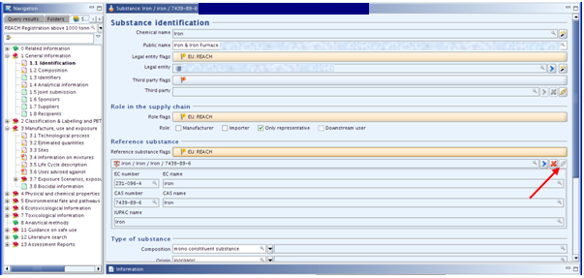

ITEM | TEXT TO BE ADDED | EXPLANATION
Substance identification | Heading only
Chemical name | Iron
Public name |  | Enter the generic name by which you describe your substance, e.g. pig iron, hot briquetted iron, etc.
Legal entity or third party flags: |  | Click on the flag if you want to assign confidentiality and programme restrictions.
Confidentiality |  | Leave blank or select the right level of confidentiality. If confidentiality is required, a justification has to be provided.
Programme restrictions |  | Select EU: REACH from pick list.
Role in the supply chain |  | Choose your role and tick appropriate box. Note:  - If “manufacturer is selected, a production site is needed in section 3.3  - “downstream user” cannot be selected if the submission covers only intermediates  - If “downstream user” is selected, “substance in article” must be ticked in section 3.4  - “only representative” cannot be selected together with “manufacturer” or “importer”
Role flags |  | Click on the flag if you want to assign confidentiality and programme restrictions.
Confidentiality |  | Leave blank or select the right level of confidentiality. If confidentiality is required, a justification has to be provided.
Programme restrictions |  | Select EU: REACH from pick list.
Reference substance | Heading only
Reference substance flag |  | Click on the flag if you want to assign confidentiality and programme restrictions.
Confidentiality |  | Leave blank or select the right level of confidentiality. If confidentiality is required, a justification has to be provided.
Programme restrictions |  | Select EU: REACH from pick list.
Reference substance | iron / iron / iron / 7439-89-6 | To locate the reference substance from the IUCLID data base, click on this icon [see red arrow in screenshot above].  Select your substance from the database by typing in the name, EC or CAS number, click SEARCH, select the substance name and click Assign [see screenshot below].  Two problems may arise:  • If no entry is found, you have first to import the substance from the EC inventory to the reference substance inventory.  • If an entry is found but inactive, right mouse click and set to “active reference substance.”  In order to simplify matters, the Iron Platform will provide reference substance files which member registrants can import into their IUCLID dossiers.
EC number / name |  | This information is automatically provided when the reference substance is assigned
CAS number |  | This information is automatically provided when the reference substance is assigned
IUPAC name |  | This information is automatically provided when the reference substance is assigned
Type of substance: | Heading only
composition | mono constituent substance
origin | inorganic
Trade names | Heading only
Trade names flag: |  | Click on the flag if you want to assign confidentiality and programme restrictions.
Confidentiality |  | Leave blank or select the right level of confidentiality. If confidentiality is required, a justification has to be provided.
Programme restrictions |  | Select EU: REACH from pick list.
Name |  | If you have trade name[s] for your substance, add it/them here
Contact person |  | These fields are for your own company information. The details entered should correspond with the information contained in REACH-IT. Several contacts can be provided. Click on to add one.

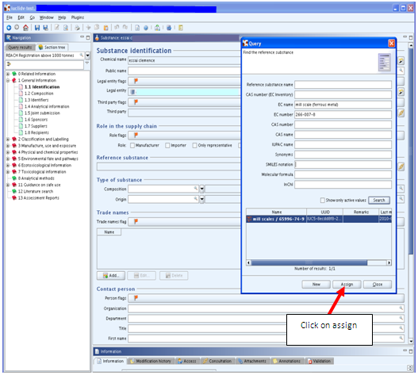

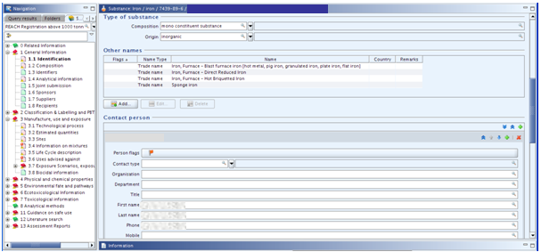

1.2 COMPOSITION

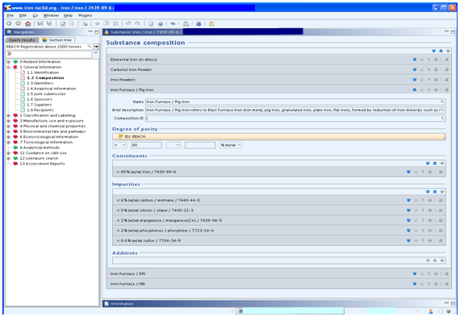

ITEM | TEXT TO BE ADDED | EXPLANATION
Substance composition | Heading only | Create a block here for each registered form of iron
Name | Iron Furnace / Pig Iron | Enter the right name according to the registered substance(s)
 | Iron Furnace / Direct Reduced Iron
 | Iron Furnace / Hot Briquetted Iron
Brief description | Iron Furnace / Pig Iron refers to Blast Furnace Iron (hot metal, pig iron, granulated iron, plate iron, flat iron), formed by reduction of iron minerals such as iron ore lump, sinter and pellets. | Enter the right description according to the registered substance(s)
 | Direct Reduced Iron is a highly porous material, black grey metallic, formed by a reduction (removal of oxygen) of iron oxide at temperatures below the fusion point of iron
 | Hot Briquetted Iron is a metallic grey material, moulded in a briquette form, emanating from a densification process whereby the Direct Reduced Iron (DRI) feed material is moulded at a temperature greater than 650°C.
Composition ID | A number is automatically created here by IUCLID
Degree of purity flags: | Heading only | Click on the flag if you want to assign confidentiality and programme restrictions.
Confidentiality |  | Leave blank or select the right level of confidentiality. If confidentiality is required, a justification has to be provided.
Programme restrictions |  | Select EU: REACH from pick list.
Degree of purity | > 80 and % [w/w]
Constituents | Heading only | The sameness description and specification [constituents and impurities] is identical for pig iron and DRI/HBI.
Reference substance | iron / iron / iron / 7439-89-6 | To locate the reference substance from the IUCLID data base, click on this icon [as for section 1.1 above].  Select your substance from the database by typing in the name, EC or CAS number, click SEARCH, select the substance name and click Assign.  Two problems may arise:  • If no entry is found, you have first to import the substance from the EC inventory to the reference substance inventory.  • If an entry is found but inactive, right mouse click and set to “active reference substance.”  In order to simplify matters, the Iron Platform will provide reference substance files which member registrants can import into their IUCLID dossiers.
Typical concentration |  | Enter the concentration level or range for your substance here.
Concentration range | > 80 < 100 % [w/w] | This is per the sameness specification agreed by the SIEF.
Remarks |  | Enter any comments that you may wish to make with respect to the concentration level or range of your substance here.
Impurities | Heading only | Create a block for each impurity.  To locate the impurity substance from the IUCLID data base, click on this icon [as for section 1.1 above].  Select your impurity substance from the database by typing in the name, EC or CAS number, click SEARCH, select the substance name and click Assign.  Two problems may arise:  • If no entry is found, you have first to import the substance from the EC inventory to the reference substance inventory.  • If an entry is found but inactive, right mouse click and set to “active reference substance.”  In order to simplify matters, the Iron Platform will provide reference substance files for the impurities below which you can import into your IUCLID dossier.
Reference substance | carbon / carbon / carbon / 7440-44-0
Typical concentration |  | Enter the concentration level or range for your substance here.
Concentration range | > 0 < 6 % (w/w) | This is per the sameness specification agreed by the SIEF
Remarks |  | Enter any comments that you may wish to make with respect to the concentration level or range of your substance here.
Do not tick : “this impurity is considered relevant for the classification and labelling of the substance”
Impurities | Heading only | Create a new block
Reference substance | silicon / silicon / silicon / 7440-21-3
Typical concentration |  | Enter the concentration level or range for your substance here.
Concentration range | > 0 < 5 % (w/w) | This is per the sameness specification agreed by the SIEF.
Remarks |  | Enter any comments that you may wish to make with respect to the concentration level or range of your substance here.
Do not tick : “this impurity is considered relevant for the classification and labelling of the substance”
Impurities | Heading only | Create a new block
Reference substance | manganese / manganese / manganese / 7439-96-5
Typical concentration |  | Enter the concentration level or range for your substance here.
Concentration range | > 0 < 2 % (w/w) | This is per the sameness specification agreed by the SIEF.
Remarks |  | Enter any comments that you may wish to make with respect to the concentration level or range of your substance here.
Do not tick : “this impurity is considered relevant for the classification and labelling of the substance”
Impurities | Heading only | Create a new block
Reference substance | phosphorus / phosphorus / phosphorus / 7723-14-0
Typical concentration |  | Enter the concentration level or range for your substance here.
Concentration range | > 0 < 2 % (w/w) | This is per the sameness specification agreed by the SIEF.
Remarks |  | Enter any comments that you may wish to make with respect to the concentration level or range of your substance here.
Do not tick : “this impurity is considered relevant for the classification and labelling of the substance”
Impurities | Heading only | Create a new block
Reference substance | sulfur / sulfur / sulfur / 7704-34-9
Typical concentration |  | Enter the concentration level or range for your substance here.
Concentration range | > 0 < 0.4 % (w/w) | This is per the sameness specification agreed by the SIEF.
Remarks |  | Enter any comments that you may wish to make with respect to the concentration level or range of your substance here.
Do not tick : “this impurity is considered relevant for the classification and labelling of the substance”
Additives | Do not create a block here

1.3 IDENTIFIERS

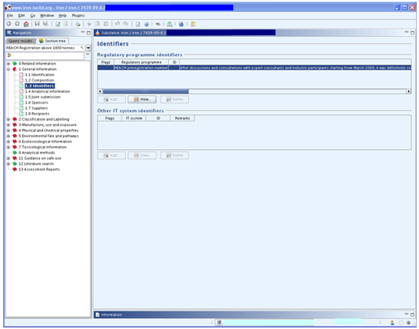

ITEM | TEXT TO BE ADDED | EXPLANATION
Regulatory programme identifiers | Heading only | Click on
Flag | Heading only | Click on the flag if you want to assign confidentiality and programme restrictions.
Confidentiality |  | Leave blank or select the right level of confidentiality. If confidentiality is required, a justification has to be provided.
Programme restrictions |  | Select EU: REACH from pick list.
Regulatory programme |  | Select REACH Pre-registration number or REACH Inquiry number from the pick list.
ID |  | Enter your pre-registration or inquiry number.
Remarks | After discussions and consultations with expert consultants and industry participants starting from March 2009, it was definitively concluded on May, 31st 2010 that Iron [Einecs number 231-096-4] and Iron, Furnace [Einecs number 265-998-4] can indeed be considered as the same substance for the purposes of REACH and that therefore the two SIEF’s should be combined as Iron [Einecs number 231-096-4, CAS number 7439-89-6]" extract from Iron-IronFurnaceSameness100531Final.pdf named "UPDATED STATEMENT ON THE SAMENESS OF IRON AND IRON, FURNACE - May, 31st 2010” | Enter this text.
Other IT system identifiers | Heading only | Leave blank

1.4 ANALYTICAL INFORMATION

For guidance on the analytical methods to use, please refer to the ANALYSIS METHODS FOR USE IN DEMONSTRATING SAMENESS - IRON document in the guidance and training for REACH registrants on the Iron Platform website.

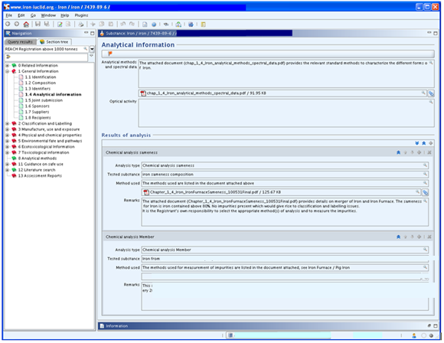

ITEM | TEXT TO BE ADDED | EXPLANATION
Analytical information flags: |  | Click on the flag if you want to assign confidentiality and programme restrictions.
Confidentiality |  | Leave blank or select the right level of confidentiality. If confidentiality is required, a justification has to be provided.
Programme restrictions |  | Select EU: REACH from pick list.
Analytical methods and spectral data |  | Attach a document describing the analytical methods used. The name of the file will automatically appear in this field.
Optical activity |  | Leave blank
Results of analysis - chemical analysis sameness | Heading only
Analysis type | Chemical analysis to prove sameness
Tested substance |  | Identify the substance tested, e.g. pig iron from ....
Analysis results |  | Attach a file with your analysis results. The name of the file will automatically appear in this field.
Method used |  | Specify the analysis method and standard in accordance with which the analysis has been carried out, e.g. XRF in accordance with ISO ...
Remarks |  | If you wish to add any remark or information about your analysis results, use this field.
Results of analysis |  | If you carried out this [or any other] test, you will need to create a new block for this section and then fill in the fields as for the preceding sections.

1.5 JOINT SUBMISSION
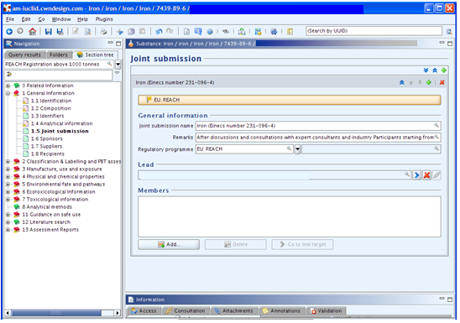
ITEM | TEXT TO BE ADDED | EXPLANATION
Joint submission | Heading only | Create a block
Joint submission flags: |  | Click on the flag if you want to assign confidentiality and programme restrictions.
Confidentiality |  | Leave blank or select the right level of confidentiality. If confidentiality is required, a justification has to be provided.
Programme restrictions |  | Select EU: REACH from pick list.
General information | Heading only
Joint submission name | Iron (Einecs number 231-096-4)
Remarks | After discussions and consultations with expert consultants and industry Participants starting from March 2009, it was definitively concluded on May, 31st 2010 that Iron [Einecs number 231-096-4] and Iron, Furnace [Einecs number 265-998-4] can indeed be considered as the same substance for the purposes of REACH and that therefore the two SIEF’s should be combined as Iron [Einecs number 231-096-4, CAS number 7439-89-6]" extract from Iron-IronFurnaceSameness100531Final.pdf named "UPDATED STATEMENT ON THE SAMENESS OF IRON AND IRON, FURNACE - May, 31st 2010” | Enter this text.
Regulatory programme |  | Leave blank or select EU: REACH.
Lead | Heading only | Leave blank
Members | Heading only | Leave blank

1.6 SPONSORS

Registrants may specify different Sponsor organisations, e.g. a Competent Authority in the context of the OECD HPV Chemicals programme or a Company in the context of the US EPA HPV Challenge programme. Otherwise leave this section blank.

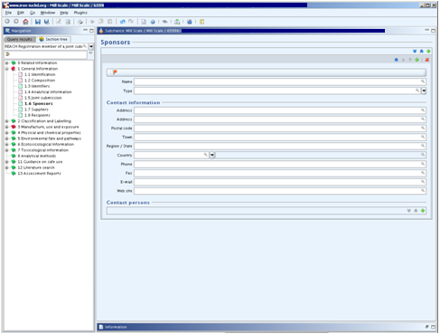

1.7 SUPPLIERS

Leave this section blank unless you are Only Representative. Although not mandatory, ECHA recommends that as an Only Representative you should attach clear documentation of your appointment as Only Representative, for example a copy of the appointment letter sent to importers. In this case you are also advised to indicate the list of importers’ names covered by the registration in the field “Other importers”. The Iron Platform strongly advises Only Representatives to follow ECHA’s recommendation.

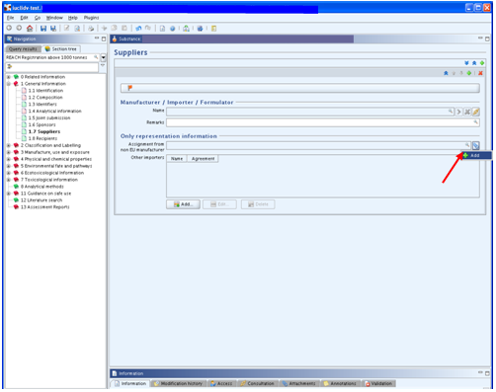

1.8 RECIPIENTS

A recipient can be a Downstream user, Distributor or Customer [e.g. in the context of Product and Process Orientated Research and Development (PPORD)] being supplied with a Substance, Mixture or Article. These definitions never include consumers.

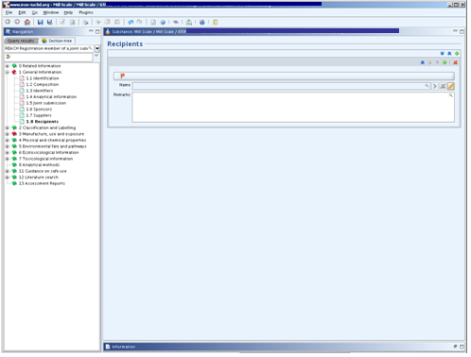

3. MANUFACTURE, USE AND EXPOSURE

3.1 TECHNOLOGICAL PROCESS

Create a block for each process, i.e. each registered form of iron
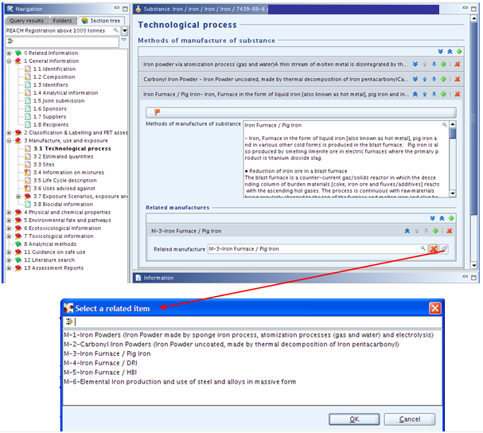

Note: the related manufacture is linked to the manufacture part of the section 3.5 – Life Cycle description. This field is not subject to TCC rules until 2014 (see ECHA Q&A on IUCLID 5.4 (April 2012) for more information). Members are free to fill in this field.

.

ITEM | TEXT TO BE ADDED | EXPLANATION
Methods of manufacture of substance | Heading only | Click on to add a block
Technological process flags: | Heading only | Click on the flag if you want to assign confidentiality and programme restrictions.
Confidentiality |  | Leave blank or select the right level of confidentiality. If confidentiality is required, a justification has to be provided.
Programme restrictions |  | Select EU: REACH from pick list.
Methods of manufacture | Iron Furnace / Pig Iron  - Iron, Furnace in the form of liquid iron [also known as hot metal], pig iron and in various other cold forms is produced in the blast furnace. Pig iron is also produced by smelting ilmenite ore in electric furnaces where the primary product is titanium dioxide slag.  • Reduction of iron ore in a blast furnace  The blast furnace is a counter-current gas/solids reactor in which the descending column of burden materials [coke, iron ore and fluxes/additives] reacts with the ascending hot gases. The process is continuous with raw materials being regularly charged to the top of the furnace and molten iron and slag being tapped from the bottom of the furnace at regular intervals.  • In the upper part of the furnace, free moisture is driven off from the burden materials and hydrates and carbonates are disassociated.  • In the lower part of the blast furnace shaft, indirect reduction of the iron oxides by carbon monoxide and hydrogen occurs at 700-1,000 C.  • In the Bosh area of the furnace where the burden starts to soften and melt, direct reduction of the iron [and other] oxides and carbonization by the coke occurs at 1,000-1,600 C. Molten iron and slag start to drip through to the bottom of the furnace [the hearth].  • Between the bosh and the hearth are the tuyeres through which the blast - combustion air, preheated to 900-1,300 C, often enriched with oxygen - is blown into the furnace. Immediately in front of the tuyeres is the combustion zone, the hottest part of the furnace, 1,850-2,200 C, where coke reacts with the oxygen and steam in the blast to form carbon monoxide and hydrogen [as well as heat] and the iron and slag melt completely.  • Molten iron and slag collect in the furnace hearth. Being less dense, the slag floats on top of the iron. Slag and iron are tapped at regular intervals through separate tap holes. For merchant pig iron production, the iron is cast into ingots; in integrated steel mills, the molten iron or hot metal is transferred in torpedo ladle cars to the steel converters. Slag is transferred to slag pits for further processing into usable materials.  The principal reactions are:  2 C + O2 → 2CO  C + H2O → CO + H2  CO2 + C → 2 CO  3 Fe2O3 + CO → CO2 + 2 Fe3O4  Fe3O4 + CO → CO2 + 3 FeO  FeO + CO → Fe + CO2  The additives and fluxes serve to convert the waste or gangue materials in the charge [mainly silica and alumina] into a low melting point slag which also dissolves the coke ash and removes sulphur. For example:  CaCO3 → CaO + CO2  CaO + SiO2 → CaSiO3  FeS + CaO + C → CaS + FeO + CO  • Smelting of ilmenite ore in an electric furnace  Pig iron is produced as a by-product [or co-product] by producers of Titanium Dioxide slag, a raw material for production of Titanium Dioxide pigments, used in the paint and plastics industries.  Ilmenite [FeTiO3] is smelted in electric arc furnaces at temperatures in the 1,650-1,700 C range, using coal or other carbonaceous materials as reductant. In some processes, the ilmenite is pre-roasted to remove sulphur and in one case, the ilmenite is pre-reduced before smelting. The principal reaction is as follows:  FeTiO3 + C = TiO2 + Fe + CO  The molten iron undergoes various metal treatment processes before being cast into ingots for sale to customers. | If you are an importer or Only Representative enter as the case may be “Importer/Only Representative - not relevant.”  EU manufacturers should create a block for each process, i.e. each registered form of iron.  This is the text submitted by the Lead Registrant - we suggest that EU manufacturers copy it unless it does not cover the method of manufacture, in which case amend or re-draft as appropriate.
Related manufactures | Heading only | Add a block by clicking on
Related manufacture |  | Click on to select the item related to pig iron
Methods of manufacture | Iron Furnace / DRI  - DRI: Direct Reduced Iron  The majority of the direct reduction processes are gas-based.  Feedstock  The iron ore feed is either fines in fluid beds or pellets and lump in the other reduction furnaces. The feedstock is prepared to adjust the size to that required in the reduction furnace. This may require screening for separation or grinding to adjust the particle size downward.  Reduction process  The process gas is formed by different methods to generate H2 and CO to remove the oxygen from the ore. In some processes, coal is also added to the process gas to actuate the reduction. Natural gas enters the reduction furnaces and is heated to the required temperature for reduction of the oxide feed.  • Lump and Pellet Feed processes  The principal shaft-based furnace operations are those of Midrex and Tenova/HYL, which together account for 98% of the gas-based processes. In these furnaces, the mixture of lump ore and pellets is introduced for reduction by different systems. The ore flows by gravity downwards and is contacted by upflowing reducing gas. The ore is reduced and heated during the downward flow. In the upwards flow, the reduction of the Fe2O3 occurs.  Products:  Once reduced, the product is either briquetted while hot as HBI (hot briquetted iron) or cooled and discharged as DRI.  • Fines Feed processes  The principal fines reactor-based furnace operation is that of FINMET, which is the only fines-based process in service in 2010. The fines are maintained in a fluidized condition by upwards flowing reducing gas. Between reactors, the ore flows by gravity downwards and is contacted in each by upflowing reducing gas. The ore is reduced and heated during the downward flow.  Products:  The fines-based processes must briquette the final product. | Click on to add a block
Related manufactures | Heading only | Add a block by clicking on
Related manufacture |  | Click on to select the item related to DRI
Methods of manufacture | Iron Furnace / HBI  - HBI: Hot Briquetted Iron  Hot briquetting is applied both for products from pellets and lump ore (shaft furnaces) and from fine ore (fluid bed reactors). Direct Reduced Iron is briquetted at high temperature and pressure with roller presses. Alternative briquette sizes and shapes have been tested in several plants. The typical volume of industrially manufactured briquettes is in the range of approx. 100 cm³.  The entire plant for the hot briquetting of direct reduced iron typically consists of:  - Briquetting press with screw feeder and material supply  - Briquette string separator (impact separator or tumbling drum)  - Hot screen for the elimination of fines which occur during briquetting and separation  - Product cooler  - Bucket elevator for the recirculation of fines to the briquetting press  - Chutes and accessories
Related manufactures | Heading only | Add a block by clicking on
Related manufacture |  | Click on to select the item related to HBI
Methods of article production | Heading only | This field has to be completed only when there is possible exposure from an article containing a substance intended for release. This field is not subject to TCC rules until 2014. Members are free to describe production of their own articles in case they have concerns.

3.2 ESTIMATED QUANTITIES

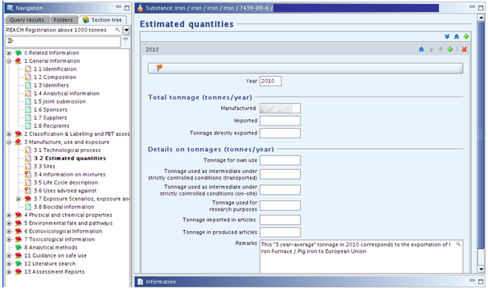

ITEM | TEXT TO BE ADDED | EXPLANATION
Year |  | Enter the current year
Estimated quantities flags: |  | Click on the flag if you want to assign confidentiality and programme restrictions.
Confidentiality |  | Leave blank or select the right level of confidentiality. If confidentiality is required, a justification has to be provided.
Programme restrictions |  | Select EU: REACH from pick list.
Total tonnage |  | If the substance has been imported or manufactured for at least three consecutive years, the tonnes per year shall be calculated on the basis of the average tonnes manufactured or imported in the three preceding calendar years. If the substance has not been manufactured or imported for three consecutive years then the tonnes manufactured or imported in a calendar year should be used (see ECHA guidance on registration, May 2012)
Details on tonnages |  | If you feel the need to provide an explanation for the basis of your tonnage, include it here.

3.3 SITES

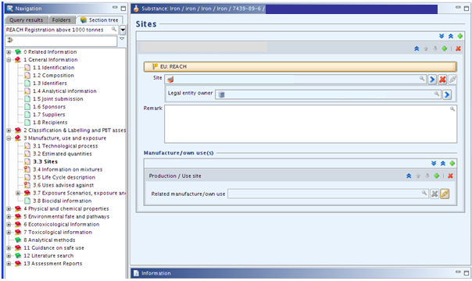

ITEM | TEXT TO BE ADDED | EXPLANATION
Sites | Heading only | Create a block by clicking on
Site |  | Click on to select an existing site or create a new site  Enter the name and location of your site(s). The minimum contact address information is town/city and country, but ECHA recommends filling all address fields.  An Only Representative or Importer can assign a site, but this is not mandatory.  If “Manufacturer” is selected in section 1.1, at least one production site must be entered in section 3.3.
Site flags: |  | Click on the flag if you want to assign confidentiality and programme restrictions.
Confidentiality |  | Leave blank or select the right level of confidentiality. If confidentiality is required, a justification has to be provided.
Programme restrictions |  | Select EU: REACH from pick list.
Legal entity owner |  | Assign the name of the legal entity which owns the site from the drop down list.
Manufacture/own use(s) |  | Create a block. Click on . Select appropriate manufacture(s) or use(s) from the section 3.5 Life Cycle description. This field is not subject to TCC rules until 2014. Members are free to fill in this field.

3.4 INFORMATION ON MIXTURES

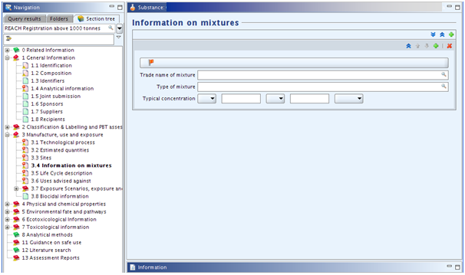

ITEM | TEXT TO BE ADDED | EXPLANATION
Information on mixtures | Heading only | Add block(s) if necessary.
Flags |  | Click on the flag if you want to assign confidentiality and programme restrictions
Confidentiality |  | Leave blank or select the right level of confidentiality. If confidentiality is required, a justification has to be provided.
Programme restrictions |  | Select EU: REACH from pick list.
Trade name of mixture |  | Enter the trade name of your mixture, for instance ferro-silicon.
Type of mixture |  | Enter a description of your mixture: e.g. lumps, ingots, briquettes…
Typical concentration |  | Insert the typical range of the concentration of the iron in the mixture. Ensure that the figure given for iron is consistent with the value[s] for other constituents given in other registration dossiers for this mixture.

3.5 LIFE CYCLE DESCRIPTION
Information on uses is available on the Iron Platform website in the document Identified uses of iron on the iron SIEF documents area. Table 1 refers to Iron Furnace / Pig Iron, Table 2 to Iron Furnace / DRI, and Table 3 to Iron Furnace / HBI.

There is conflicting advice as to whether member registrants should select only certain uses or should select them all - the advice of the Iron Platform is to select them all so as not to have to modify the dossier in the future when a new use is entered into.

The Iron Platform provides an IUCLID file containing all the uses for Iron which you can upload to your IUCLID file and then copy/paste into the corresponding fields of your substance file (IUCLID files for download). (link to i5z files here).
If you wish to specify only certain uses, create a block here by clicking on the “Add” button and tick the relevant options.

Note: New fields were added during the IUCLID upgrade to version 5.4.0. (see fields with the explanation ‘New field, you are free to fill it” in the table below). These fields are not subject to TCC rules until 2014 (see ECHA Q&A on IUCLID 5.4 (April 2012) for more information). However, member registrants are free to fill them in if they wish.

ITEM | TEXT TO BE ADDED | EXPLANATION
Life Cycle description | Heading only
Generic information | Heading only
Justification why no identified uses are reported |  | Leave blank - unless you have not added uses below in which case select in the pick list the justification about the absence of reported uses
Manufacture | Heading only
Manufacture name
Tonnage of the substance |  | New field, you are free to fill it
Number of sites range |  | New field, you are free to fill it
Environmental Release Category |  | Select relevant options in the picklist
Process Category
Use coverage in CSR |  | New field, you are free to fill it
Formulation | Heading only
Identified use name
Brief description of use process
Tonnage of the substance |  | New field, you are free to fill it
Number of sites range |  | New field, you are free to fill it
Environmental Release Category |  | Select relevant options in the picklist
Process Category
Product Category formulated
Technical function of the substance during formulation
Substance supplied to that use in form of
Use coverage in CSR |  | New field, you are free to fill it
Use at industrial site
Identified use name
Brief description of use process |  | New field, you are free to fill it
Tonnage of substance |  | New field, you are free to fill it
Number of sites range |  | New field, you are free to fill in
Environmental Release Category |  | Select relevant options in the picklist
Process Category
Product Category used
Sector of end use
Technical function of the substance
Substance supplied to that use in the form of
Subsequent service life relevant for that use
Link to subsequent service life |  | New field, you are free to fill it
Use coverage in CSR |  | New field, you are free to fill it
Consumer Uses | Heading only
Article service life | Heading only
Service life name
Tonnage of substance |  | New field, you are free to fill it
Article used by
Article category related to subsequent service life
Further description of article |  | New field, you are free to fill it
Exposure related description of article |  | New field, you are free to fill it
Environmental Release Category |  | Select relevant options in the picklist
Process Category for articles used by workers
Typical concentration of the substance in article % |  | New field, you are free to fill it
Technical function of the substance |  | Select relevant options in the picklist
Use coverage in CSR |  | New field, you are free to fill it

3.6 USES ADVISED AGAINST

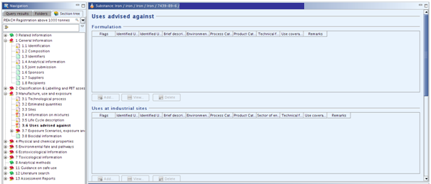
Do not create a block for section 3.6 and leave it blank as there are no uses advised against.

3.7 Exposure Scenarios, exposure and risk assessment
The former section 3.7 Waste from production and use (IUCLID 5.3 and former versions) is attached as an html file in the section 3. Delete it if you need to update and resubmit your dossier since html attachments are not supported by ECHA business rules checks.
The former section “3.8 Exposure estimates” was replaced by the following subparts.

3.7.1 Exposure scenarios and local assessment
Note: This part was added in June 2012 during the upgrade to IUCLID 5.4.0. It will be taken into account by the TCC in 2014.
No endpoint should be created; the substance is not classified, hence no exposure scenario should be developed.

3.7.2 Environmental assessment for aggregated sources
Note: This part has been added in June 2012 during the upgrade to IUCLID 5.4.0. It will be taken into account by the TCC in 2014.
This section should be left blank since the substance is not classified.

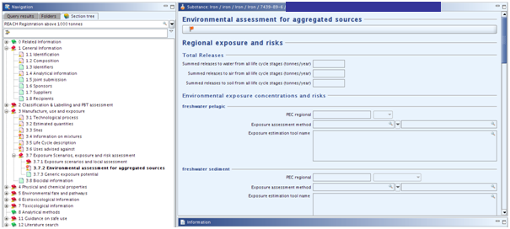

3.7.3 Generic exposure potential
Note: this section was previously part of the former 3.5 Identified uses.
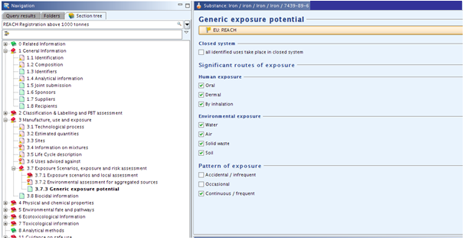

ITEM | TEXT TO BE ADDED | EXPLANATION
Flags |  | Click on the flag if you want to assign confidentiality and programme restrictions
Confidentiality |  | Leave blank or select the right level of confidentiality. If confidentiality is required, a justification has to be provided.
Programme restrictions |  | Select EU: REACH from pick list.
Closed system |  | This box should be ticked when the substance is used in a closed system, such as the use of liquids in hydraulic systems, cooling liquids in refrigerators and lubricants in engines and dielectric fluids in electric transformers and oil in heat exchangers.
Significant routes of exposure |  | Either tick the same boxes as the Lead Registrant or make your own selection as appropriate. The Lead Registrant has ticked the following boxes:  Human exposure:  - Oral  - Dermal  - By inhalation  Environmental exposure:  - Water  - Air  - Solid waste  - Soil  Pattern of exposure:  - Continuous / frequent

3.8 BIOCIDAL INFORMATION

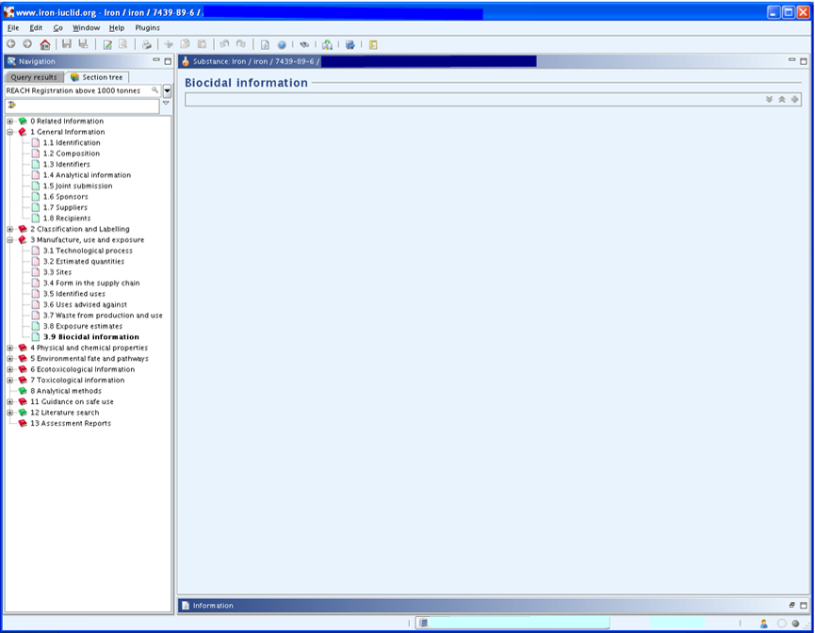

Section 3.8 should be left blank as it is not relevant in this case - do not create a block for it.

RECOMMENDATIONS CONCERNING SUBMISSION

Before submitting your dossier, do not forget to:
- check your substance file with the TCC Tool plug-in:
- If TCC fails, correct all mistakes or create a new substance file
- If TCC passes, go to the next step
- create a dossier by right clicking on your substance
- check your dossier file
- If TCC fails, create a new dossier file
- If TCC passes, go to the next step
- export your dossier file on your computer by right clicking on the dossier
- open your account on ECHA REACH-IT
- if the dossier file size is larger than 20MB => request a large file access code before submission on ECHA REACH-IT [it is normally immediate and you will receive the code in your REACH-IT message box]
- follow the prompts to submit your dossier file [for more detailed information, please consult the ECHA Guidance on submission (July 2012)]

After submission:
- check your message box in ECHA REACH-IT to follow progress of ECHA’s 14 dossier examination steps via the submission report;
- take the necessary actions, for example paying the registration fee.

Disclaimer: The Iron Platform and Iron Platform Services Ltd. do not make any representations or warranties in relation to the content of this guidance document. In particular, the Iron Platform and Iron Platform Services Ltd. do not make any representations or warranties regarding the accuracy, timeliness or completeness of its content. The Iron Platform and Iron Platform Services Ltd. will not be responsible for any loss or damage caused by relying on the content contained in this document.

Document history:

Date | Version - Main changes
October 16th, 2012 | Minor format changes
August 13th, 2012 | Changes to fit the new IUCLID version (5.4.0)
October 16th, 2010 | Minor changes
August 25th, 2010 | First version

