GUIDANCE ON COMPLETION OF SECTIONS 1 AND 3 OF THE IUCLID 5 DOSSIER:
MILL SCALE [EINECS NUMBER 266-007-8, CAS NUMBER 65996-74-9]

INTRODUCTION 2
1. GENERAL INFORMATION 3
1.1 IDENTIFICATION 3
1.2 COMPOSITION 6
1.3 IDENTIFIERS 8
1.4 ANALYTICAL INFORMATION 9
1.5 JOINT SUBMISSION 11
1.6 SPONSORS 12
1.7 SUPPLIERS 13
1.8 RECIPIENTS 14
3. MANUFACTURE, USE AND EXPOSURE 15
3.1 TECHNOLOGICAL PROCESS 15
3.2 ESTIMATED QUANTITIES 18
3.3 SITES 19
3.4 INFORMATION ON MIXTURES 20
3.5 LIFE CYCLE DESCRIPTION 21
3.6 USES ADVISED AGAINST 22
3.7 Exposure Scenarios, exposure and risk assessment 23
3.7.1 Exposure scenarios and local assessment 23
3.7.2 Environmental assessment for aggregated sources 23
3.7.3 Generic exposure potential 24
3.8 BIOCIDAL INFORMATION 25
RECOMMENDATIONS CONCERNING SUBMISSION 25

INTRODUCTION
This document details the information submitted by the Lead Registrant for Mill Scale and is intended as a guide to member registrants for completion of the necessary fields of sections 1 and 3 of their IUCLID 5.4 dossiers for Mill Scale.

Note however that the text of REACH Regulation is the only authentic legal reference and the information contained in this document does not constitute legal advice. It is therefore recommended that member registrants should read all relevant ECHA Guidance documents, for example Practical Guide 9: How to do a registration as a member of a joint submission (August 2010).

Member registrants should make themselves aware of all new updates of the IUCLID software and its plug-ins (IUCLID installation kit).

This document contains two types of information:

- that which will be common to all dossiers which are part of the Joint Submission for Mill Scale - the cells for which in this document are highlighted in orange;
- that which is particular to your company - the cells for which in this document are highlighted in blue;
- Cells highlighted in grey relate to headings only and have no content.
In order to input data to fields, please click on the EDIT button or select Control-E.
Do not forget to save data entered by clicking on the save button.

Do not forget to check your substance and dossier files with the IUCLID 5.4 Technical Completeness Check (TCC) plug-in tool [don’t forget to update this plug-in].

If confidentiality is required, the registration fee will be more expensive and a justification has to be provided! Note that ECHA has issued in July 2012 a guidance document on confidentiality claims - this can be downloaded from the ECHA website - Data submission manuals or from the Library page of the Iron Platform website.

A fee calculator plug-in is available. This plug-in assists Legal Entities in calculating fees associated to REACH or CLP dossiers.

Information on the creation of a new substance is available on the Iron Platform website in the SLIDES FROM IUCLID AND REACH-IT WEBINAR 08/07/2010 [slides 14-20]. Member registrants will have to import all IUCLID files [reference substances and the file containing the uses] provided by the Iron Platform before creating their substance files. A guidance document “How to import an i5z file into IUCLID 5.2” is available on the Iron Platform website [also applicable for IUCLID version 5.4].

An IUCLID 5.4 dissemination plug-in is available. This allows a registrant to preview or simulate the information from its registration dossier that ECHA will make available via the internet. You can find more information on disseminated data in the ECHA Data Submission Manual, Part 15 - Dissemination (July 2012) and its Technical annex for IUCLID section 1, 2, 3 (July 2012) - these documents are also available on the Library page of the Iron Platform website.

Note: The new version of IUCLID does not have an impact on TCC requirements for the moment. New fields related to the CSR information will not be subject to TCC until 2014 (see ECHA Q&A on IUCLID 5.4 (April 2012) for more information - also on the Library page of the Iron Platform website.). Members are free to fill in these new fields.

1. GENERAL INFORMATION

1.1 IDENTIFICATION
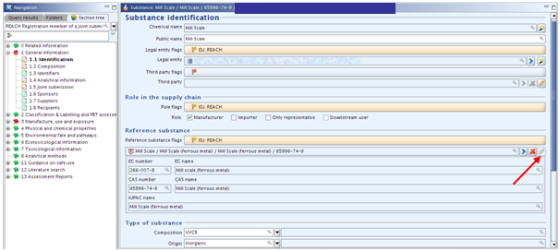

ITEM | TEXT TO BE ADDED | EXPLANATION
Substance identification | Heading only
Chemical name | Mill scale
Public name |  | Enter the generic name by which you describe your substance, e.g. mill scale.
Legal entity or third party flags: |  | Click on the flag if you want to assign confidentiality and programme restrictions.
Confidentiality |  | Leave blank or select the right level of confidentiality. If confidentiality is required, a justification has to be provided.
Programme restrictions |  | Select EU: REACH from pick list.
Role in the supply chain |  | Choose your role and tick appropriate box. Note: if “manufacturer is selected, a production site is needed in section 3.3  “downstream user” cannot be selected if the submission covers only intermediates  If “downstream user” is selected, “substance in article” must be ticked in section 3.4  “only representative” cannot be selected together with “manufacturer” or “importer”
Role flags |  | Click on the flag if you want to assign confidentiality and programme restrictions.
confidentiality |  | Leave blank or select the right level of confidentiality. If confidentiality is required, a justification has to be provided.
programme restrictions |  | Select EU: REACH from pick list.
Reference substance | Heading only
Reference substance flag |  | Click on the flag if you want to assign confidentiality and programme restrictions.
Confidentiality |  | Leave blank or select the right level of confidentiality. If confidentiality is required, a justification has to be provided.
Programme restrictions |  | Select EU: REACH from pick list.
Reference substance | Mill Scale / Mill Scale (ferrous metal) / Mill Scale (ferrous metal) / 65996-74-9 | To locate the reference substance from the IUCLID data base, click on this icon [see red arrow in screenshot above].  Select your substance from the database by typing in the name, EC or CAS number, click SEARCH, select the substance name and click Assign [see screenshot below].  Two problems may arise:  • If no entry is found, you have first to import the substance from the EC inventory to the reference substance inventory.  • If an entry is found but inactive, right mouse click and set to “active reference substance.”  In order to simplify matters, the Iron Platform provides reference substance files which member registrants can import into their IUCLID dossiers.
EC number / name |  | This information is automatically provided when the reference substance is assigned.
CAS number |  | This information is automatically provided when the reference substance is assigned.
IUPAC name |  | This information is automatically provided when the reference substance is assigned.
Type of substance: | Heading only
composition | UVCB
origin | inorganic
Trade names | Heading only
Trade names flag: |  | Click on the flag if you want to assign confidentiality and programme restrictions.
confidentiality |  | Leave blank or select the right level of confidentiality. If confidentiality is required, a justification has to be provided.
programme restrictions |  | Leave blank or select EU: REACH.
Name |  | If you have trade name[s] for your substance, add it/them here.
Contact person |  | These fields are for your own company information. The details entered should correspond with the information contained in REACH-IT. Several contacts can be provided. Click on to add one.

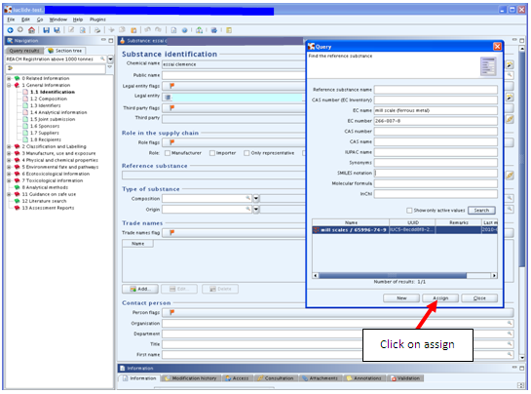

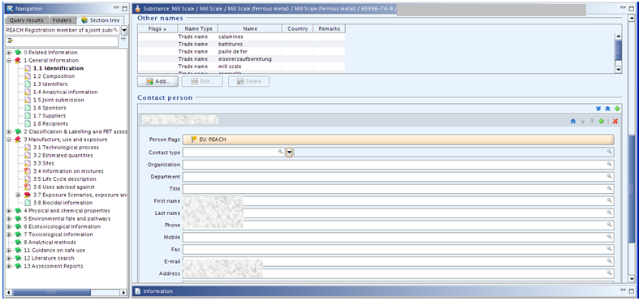

1.2 COMPOSITION

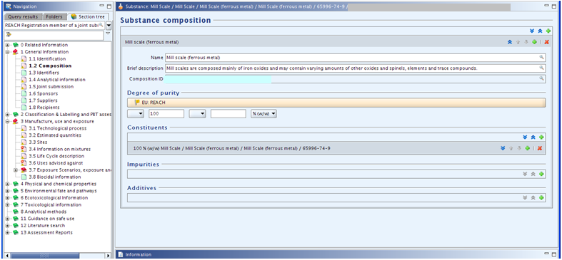

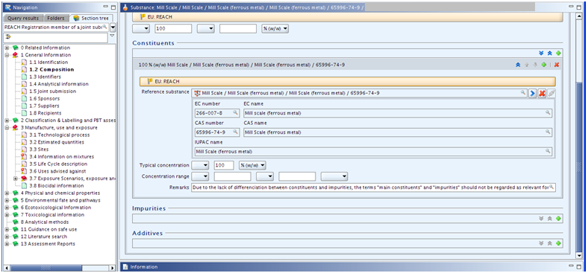

ITEM | TEXT TO BE ADDED | EXPLANATION
Substance composition | Heading only | Create a block here
Name | Mill scale (ferrous metal)
Brief description | Mill scales are composed mainly of iron oxides and may contain varying amounts of other oxides and spinels, elements and trace compounds. | This “brief” description is limited by the size of the field.
Composition ID |  | A number is automatically created here by IUCLID
Degree of purity flags: | Heading only | Click on the flag if you want to assign confidentiality and programme restrictions.
confidentiality |  | Leave blank or select the right level of confidentiality. If confidentiality is required, a justification has to be provided.
programme restrictions |  | Select EU: REACH from pick list.
Degree of purity | 100 and % [w/w]
Constituents | Heading only | The text is automatically created by IUCLID
Reference substance | Mill Scale / Mill Scale (ferrous metal) / Mill Scale (ferrous metal) / 65996-74-9 | To locate the reference substance from the IUCLID data base, click on this icon [see section 1.1 above].  Select your substance from the database by typing in the name, EC or CAS number, click SEARCH, select the substance name and click Assign.  Two problems may arise:  • If no entry is found, you have first to import the substance from the EC inventory to the reference substance inventory.  • If an entry is found but inactive, right mouse click and set to “active reference substance.”  In order to simplify matters, the Iron Platform will provide reference substance files which member registrants can import into their IUCLID dossiers.
Typical concentration | 100% [w/w]
Concentration range |  | Leave blank
Remarks | Due to the lack of differentiation between constituents and impurities, the terms "main constituents" and "impurities" should not be regarded as relevant for UVCB substances (Ref. ECHA - Guidance for identification and naming of substances under REACH - Section 4.3.1.1 Information on chemical composition). | Enter this text.
Impurities | Heading only | Do not create a block here.
Additives | Heading only | Do not create a block here.

1.3 IDENTIFIERS

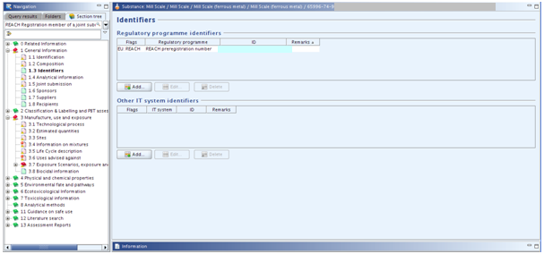

ITEM | TEXT TO BE ADDED | EXPLANATION
Regulatory programme identifiers | Heading only | Click on
Flag | Heading only | Click on the flag if you want to assign confidentiality and programme restrictions.
Confidentiality |  | Leave blank or select the right level of confidentiality. If confidentiality is required, a justification has to be provided.
Programme restrictions |  | Select EU: REACH from pick list.
Regulatory programme |  | Select REACH Pre-registration number or REACH Inquiry number from the pick list.
ID |  | Enter your pre-registration or inquiry number.
Remarks |  | Leave blank
Other IT system identifiers | Heading only | Leave blank

1.4 ANALYTICAL INFORMATION

For guidance on the analytical methods to use, please refer to our Compositions and Analysis guidance document for Mill Scale.
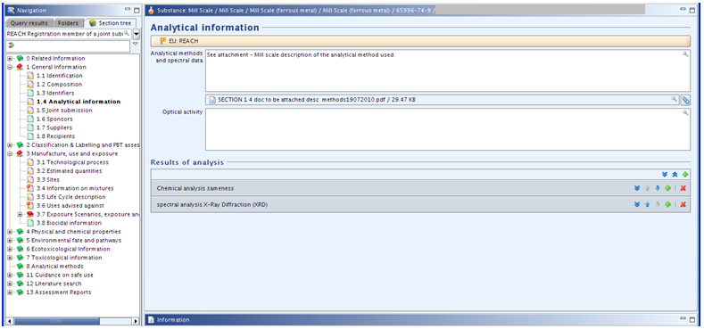

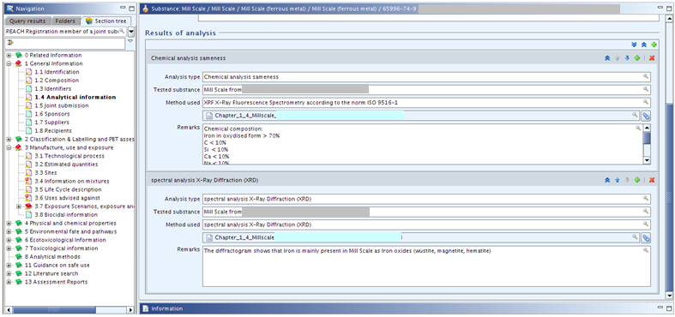

ITEM | TEXT TO BE ADDED | EXPLANATION
Analytical information flags: |  | Click on the flag if you want to assign confidentiality and programme restrictions.
confidentiality |  | Leave blank or select the right level of confidentiality. If confidentiality is required, a justification has to be provided.
programme restrictions |  | Select EU: REACH from pick list.
Analytical methods and spectral data |  | Attach a document describing the analytical methods used.
Optical activity | Not applicable for inorganic substances
Results of analysis - chemical analysis | Heading only | Create a block by clicking on
Analysis type | Chemical analysis to prove sameness
Tested substance |  | Identify the substance tested, e.g. mill scale from.....
Analysis results |  | Attach a file with your analysis data. The name of the file will automatically appear in this field.
Method used |  | Specify the analysis method and standard in accordance with which the analysis has been carried out, e.g. XRF in accordance with ISO ...
Remarks |  | The Lead Registrant has entered the sameness specification is this remarks field as follows:  “Sameness composition:  Iron in oxidised form > 70%  Si < 10%  Al < 10%  Ca < 10%  Na < 10%  Mn < 10%  C < 10%  Other compounds not CLP classified  No substances leading to a CLP classification  Oil content: <1% for all the uses and <3% for batteries and Melting charge”
Results of analysis - spectral analysis X-Ray diffraction [XRD] |  | You will need to create a new block for this section.
Analysis type |  | Specify the name of the method used for this analysis, e.g. “spectral analysis X-Ray Diffraction.”
Tested substance |  | Identify the substance tested, e.g. mill scale from.....
Analysis results |  | Attach a file with your analysis data. The name of the file will automatically appear in this field.
Method used |  | Specify your analysis method, e.g. “spectral analysis X-Ray Diffraction.”
Remarks |  | You may wish to insert a summary of the conclusion from your XRD analysis, e.g. “The diffractogram shows that Iron is mainly present in Mill Scale as Iron oxides (wüstite, magnetite, hematite).”
Results of analysis |  | If you carried or any other test, you will need to create a new block for this section and then fill in the fields as for the preceding sections.

1.5 JOINT SUBMISSION

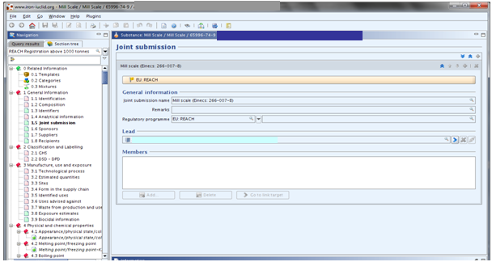

ITEM |  | TEXT TO BE ADDED |  | EXPLANATION
 | Joint submission |  | Heading only |  | Create a block
Joint submission flags: |  |  |  | Click on the flag if you want to assign confidentiality and programme restrictions.
confidentiality |  |  |  | Leave blank or select the right level of confidentiality. If confidentiality is required, a justification has to be provided.
programme restrictions |  |  |  | Select EU: REACH from pick list.
 | General information |  | Heading only
Joint submission name |  | Mill scale (Einecs: 266-007-8) |  | Member registrants have to enter this information
Remarks |  |  |  | Leave blank
 | Regulatory programme |  |  |  | Select EU: REACH.
Lead |  | Heading only |  | Leave blank
Members |  | Heading only |  | Leave blank

1.6 SPONSORS

Registrants may specify different Sponsor organisations, e.g. a Competent Authority in the context of the OECD HPV Chemicals programme or a Company in the context of the US EPA HPV Challenge programme. Otherwise leave this section blank.

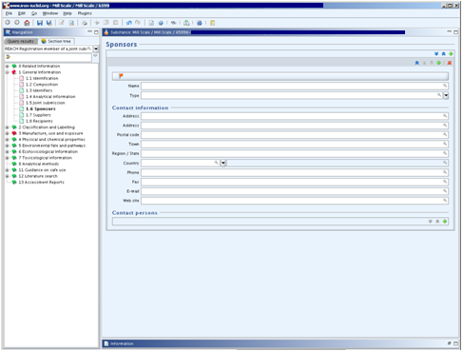

1.7 SUPPLIERS

Leave this section blank unless you are Only Representative. Although not mandatory, ECHA recommends that as an Only Representative you should attach clear documentation of your appointment as Only Representative, for example a copy of the appointment letter sent to importers. In this case you are also advised to indicate the list of importers’ names covered by the registration in the field “Other importers”. The Iron Platform strongly advises Only Representatives to follow ECHA’s recommendation.

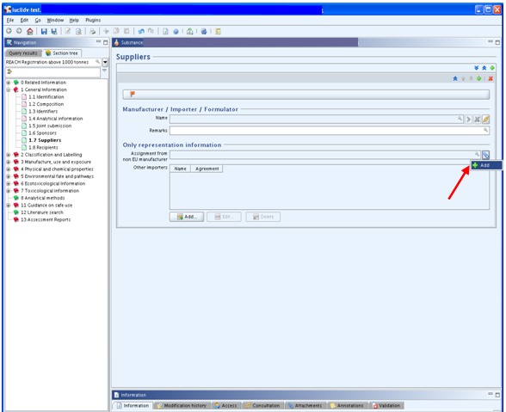

1.8 RECIPIENTS

A recipient can be a Downstream user, Distributor or Customer [e.g. in the context of Product and Process Orientated Research and Development (PPORD)] being supplied with a Substance, Mixture or Article. These definitions never include consumers.

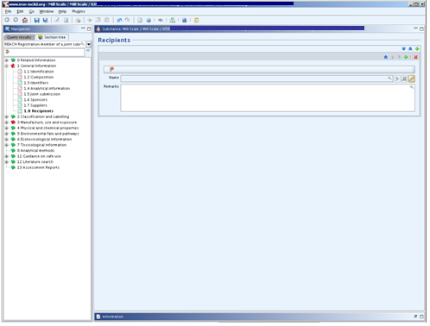

3. MANUFACTURE, USE AND EXPOSURE

3.1 TECHNOLOGICAL PROCESS

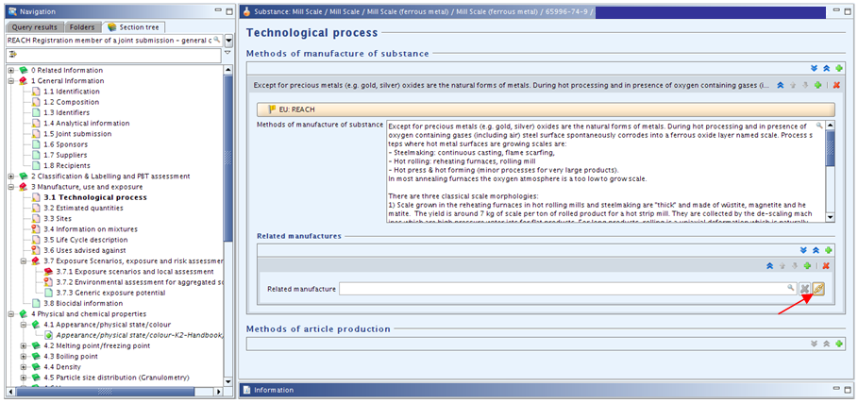

Note: the related manufacture is linked to the manufacture part of the section 3.5 – Life Cycle description. This field is not subject to TCC rules until 2014 (see ECHA Q&A on IUCLID 5.4 (April 2012) for more information). Members are free to fill in this field.

ITEM | TEXT TO BE ADDED | EXPLANATION
Methods of manufacture of substance | Heading only | Click on to add a block
Technological process flags: | Heading only | Click on the flag if you want to assign confidentiality and programme restrictions.
confidentiality |  | Leave blank or select the right level of confidentiality. If confidentiality is required, a justification has to be provided.
programme restrictions |  | Select EU: REACH from pick list.
Methods of manufacture | Except for precious metals [e.g. gold, silver] oxides are the natural forms of metals. During hot processing and in presence of oxygen containing gases [including air] a steel surface spontaneously corrodes into a ferrous oxide layer named scale. Process steps where hot metal surfaces are growing scales are:  Steelmaking: continuous casting, flame scarfing;  Hot rolling: reheating furnaces, rolling mill;  Hot press & hot forming [minor processes for very large products].  In most annealing furnaces the oxygen atmosphere is a too low to grow scale.  There are three classical scale morphologies:  1) Scale grown in the reheating furnaces in hot rolling mills and steelmaking are "thick" and made of wüstite, magnetite and hematite. The yield is around 7 kg of scale per ton of rolled product for a hot strip mill. They are collected by the de-scaling machines which are high pressure water jets for flat products. For long products, rolling is a uni-axial deformation which is naturally removing scale; scale is collected directly at rolling stands.  2) Scale grown later in the hot rolling mill itself is thinner and made of wüstite, magnetite and hematite. Only one part is collected by the de-scaling stand [2.5 kg/t for HSM], the remaining part is left on black coils [in the order 10 kg/t HSM].  Both types of scale have the same chemical composition and are mixed during collection. They cannot be distinguished later.  3) Mill scales obtained during pickling process which are thin made of mainly magnetite with smaller amounts of wüstite and hematite. The yield is around 10 kg of scale per ton of rolled product.  Alloying elements [atoms different from iron] are initially part of the steel matrix; this is the case for Cr and Ni which are major components of stainless steels.  All alloying elements can be transferred into scale during oxidation.  The only exception is carbon which builds a gaseous oxide; this gas is included in the fumes of the reheating furnace.  Manganese oxides are in solution inside iron oxides.  Other alloying elements create a different phase which is deeply embedded in wüstite.  Based on the binding condition there is no possibility to separate these phases by physical treatment. | If you are an importer or Only Representative enter as the case may be “Importer/Only Representative - not relevant.”  This is the text submitted by the Lead Registrant - we suggest that EU manufacturers copy it unless it does not cover the method of manufacture, in which case amend or re-draft as appropriate.
Related manufactures | Heading only | Add a block by clicking on
Related manufacture |  | Click on to select the item related to mill scale manufacture
Methods of article production | Heading only | This field has to be completed only when there is possible exposure from an article containing a substance intended for release. This field is not subject to TCC rules until 2014. Members are free to describe production of their own articles in case they have concerns.

3.2 ESTIMATED QUANTITIES

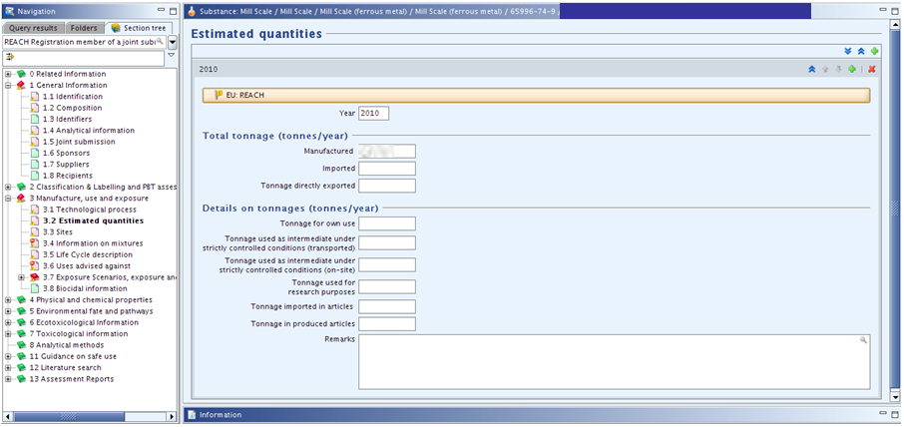

ITEM | TEXT TO BE ADDED | EXPLANATION
Estimated quantities | Heading only | Click on to add a block
Estimated quantities flags: |  | Click on the flag if you want to assign confidentiality and programme restrictions.
confidentiality |  | Leave blank or select the right level of confidentiality. If confidentiality is required, a justification has to be provided.
programme restrictions |  | Select EU: REACH from pick list.
Year |  | Enter the current year
Total tonnage |  | If the substance has been imported or manufactured for at least three consecutive years, the tonnes per year shall be calculated on the basis of the average tonnes manufactured or imported in the three preceding calendar years. If the substance has not been manufactured or imported for three consecutive years then the tonnes manufactured or imported in a calendar year should be used (see ECHA guidance on registration, May 2012)
Details on tonnages |  | If you feel the need to provide an explanation for the basis of your tonnage, include it here.

3.3 SITES

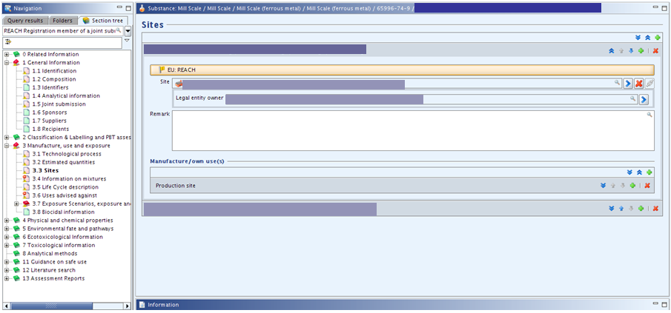

ITEM | TEXT TO BE ADDED | EXPLANATION
Sites | Heading only | For each one of your site affiliated to the Legal Entity, create a block by clicking on
Site flags |  | Click on the flag if you want to assign confidentiality and programme restrictions.
confidentiality |  | Leave blank or select the right level of confidentiality. If confidentiality is required, a justification has to be provided.
programme restrictions |  | Select EU: REACH from pick list.
Site |  | Click on to select an existing site or create a new site  Enter the name and location of your site(s). The minimum contact address information is town/city and country, but ECHA recommends filling all address fields.  An Only Representative or Importer can assign a site, but this is not mandatory.  If “Manufacturer” is selected in section 1.1, at least one production site must be entered in section 3.3.
Legal entity owner |  | Assign the name of the legal entity which owns the site from the drop down list.
Remark |  | Enter any comments that you may wish to make with respect to the site.
Manufacture/own use(s) |  | Create a block. Click on . Select appropriate manufacture(s) or use(s) from the section 3.5 Life Cycle description. This field is not subject to TCC rules until 2014. Members are free to fill in this field.

3.4 INFORMATION ON MIXTURES

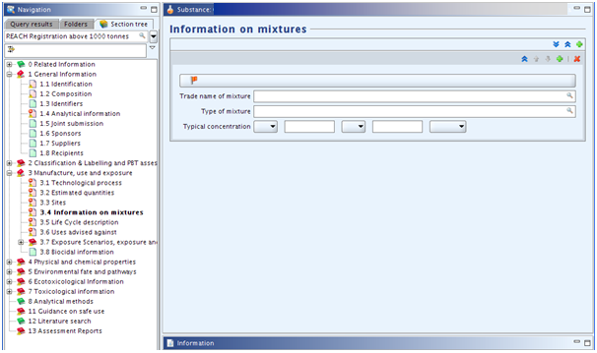
ITEM | TEXT TO BE ADDED | EXPLANATION
Information on mixtures | Heading only | Leave blank or add block(s) if relevant.
Flags |  | Click on the flag if you want to assign confidentiality and programme restrictions
Confidentiality |  | Leave blank or select the right level of confidentiality. If confidentiality is required, a justification has to be provided.
Programme restrictions |  | Select EU: REACH from pick list.
Trade name of mixture |  | Enter the trade name of your mixture
Type of mixture |  | Enter a description of your mixture: e.g. granular…
Typical concentration |  | Insert the typical range of the concentration of mill scale contained in the mixture. Ensure that the figure given for mill scale is consistent with the value[s] for other constituents given in other registration dossiers for this mixture.

3.5 LIFE CYCLE DESCRIPTION
There is conflicting advice as to whether member registrants should select only certain uses or should select them all - the advice of the Iron Platform is to select them all so as not to have to modify the dossier in the future when a new use is entered into.

The Iron Platform provides an IUCLID file containing all the uses for mill scale which you can upload to your IUCLID file and then copy/paste into the corresponding fields of your substance file (IUCLID files for download). (link to i5z files here).
If you wish to specify only certain uses, create a block here by clicking on the “Add” button and tick the relevant options.

Note: New fields were added during the IUCLID upgrade to version 5.4.0. (see fields with the explanation ‘New field, you are free to fill it” in the table below). These fields are not subject to TCC rules until 2014 (see ECHA Q&A on IUCLID 5.4 (April 2012) for more information). However, member registrants are free to fill them in if they wish.

ITEM | TEXT TO BE ADDED | EXPLANATION
Life Cycle description | Heading only
Generic information | Heading only
Justification why no identified uses are reported |  | Leave blank - unless you have not added uses below in which case select in the pick list the justification about the absence of reported uses
Manufacture | Heading only
Manufacture name
Tonnage of the substance |  | New field, you are free to fill it
Number of sites range |  | New field, you are free to fill it
Environmental Release Category |  | Select relevant options in the picklist
Process Category
Use coverage in CSR |  | New field, you are free to fill it
Formulation | Heading only
Identified use name
Brief description of use process
Tonnage of the substance |  | New field, you are free to fill it
Number of sites range |  | New field, you are free to fill it
Environmental Release Category |  | Select relevant options in the picklist
Process Category
Product Category formulated
Technical function of the substance during formulation
Substance supplied to that use in form of
Use coverage in CSR |  | New field, you are free to fill it
Use at industrial site | Heading only
Identified use name
Brief description of use process |  | New field, you are free to fill it
Tonnage of substance |  | New field, you are free to fill it
Number of sites range |  | New field, you are free to fill in
Environmental Release Category |  | Select relevant options in the picklist
Process Category
Product Category used
Sector of end use
Technical function of the substance
Substance supplied to that use in the form of
Subsequent service life relevant for that use
Link to subsequent service life |  | New field, you are free to fill it
Use coverage in CSR |  | New field, you are free to fill it
Consumer Uses | Heading only
Article service life | Heading only
Service life name
Tonnage of substance |  | New field, you are free to fill it
Article used by
Article category related to subsequent service life
Further description of article |  | New field, you are free to fill it
Exposure related description of article |  | New field, you are free to fill it
Environmental Release Category |  | Select relevant options in the picklist
Process Category for articles used by workers
Typical concentration of the substance in article % |  | New field, you are free to fill it
Technical function of the substance |  | Select relevant options in the picklist
Use coverage in CSR |  | New field, you are free to fill it

3.6 USES ADVISED AGAINST

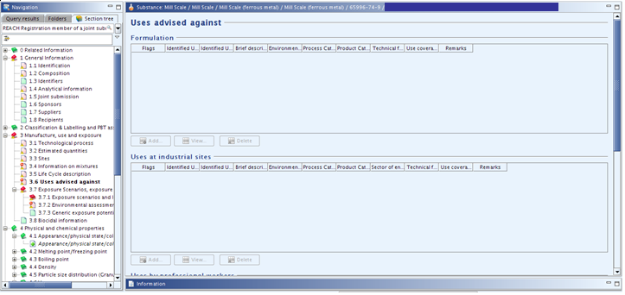

Do not create a block for section 3.6 - leave it blank as there are no uses advised against.

3.7 Exposure Scenarios, exposure and risk assessment
The former section 3.7 Waste from production and use (IUCLID 5.3 and former versions) is attached as an html file in the section 3. Delete it if you need to update and resubmit your dossier since html attachments are not supported by ECHA business rules checks.
The former section “3.8 Exposure estimates” was replaced by the following subparts.

3.7.1 Exposure scenarios and local assessment
Note: This part was added in June 2012 during the upgrade to IUCLID 5.4.0. It will be taken into account by the TCC in 2014.
No endpoint should be created; the substance is not classified, hence no exposure scenario should be developed.

3.7.2 Environmental assessment for aggregated sources
Note: This part has been added in June 2012 during the upgrade to IUCLID 5.4.0. It will be taken into account by the TCC in 2014.
This section should be left blank since the substance is not classified.

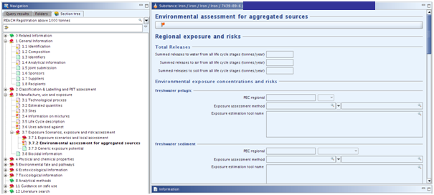

3.7.3 Generic exposure potential
Note: this section was previously part of the former 3.5 Identified uses.
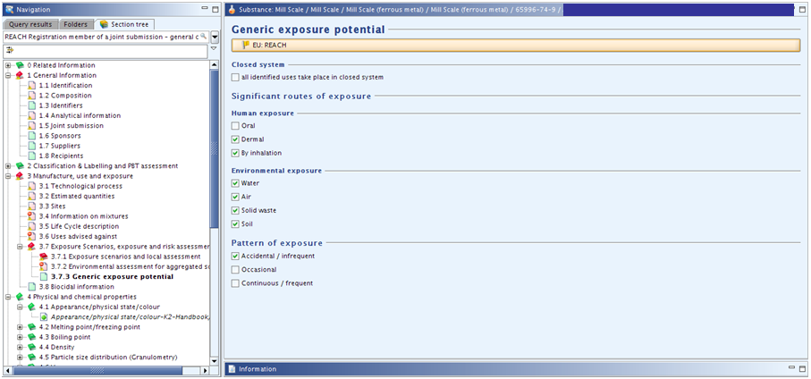

ITEM | TEXT TO BE ADDED | EXPLANATION
Flags |  | Click on the flag if you want to assign confidentiality and programme restrictions
Confidentiality |  | Leave blank or select the right level of confidentiality. If confidentiality is required, a justification has to be provided.
Programme restrictions |  | Select EU: REACH from pick list.
Closed system |  | This box should be ticked when the substance is used in a closed system, such as the use of liquids in hydraulic systems, cooling liquids in refrigerators and lubricants in engines and dielectric fluids in electric transformers and oil in heat exchangers.
Significant routes of exposure |  | Either tick the same boxes as the Lead Registrant or make your own selection as appropriate. The Lead Registrant has ticked the following boxes:  Human exposure:  - Dermal  - By inhalation  Environmental exposure:  - Water  - Air  - Solid waste  - Soil  Pattern of exposure:  - Accidental / infrequent

3.8 BIOCIDAL INFORMATION

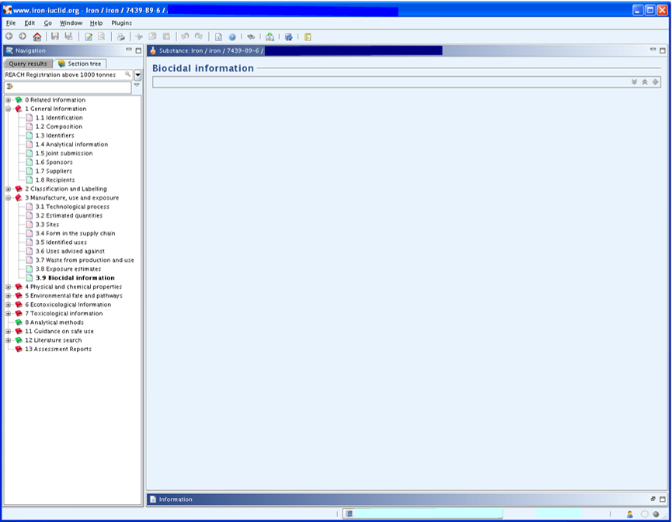
Section 3.8 should be left blank as this substance is not classified - do not create a block for it.

RECOMMENDATIONS CONCERNING SUBMISSION

Before submitting your dossier, do not forget to:
- check your substance file with the TCC Tool plug-in:
- If TCC fails, create a new substance file
- If TCC passes, go to the next step
- create a dossier by right clicking on your substance
- check your dossier file
- If TCC fails, create a new dossier file
- If TCC passes, go to the next step
- export your dossier file on your computer by right clicking on the dossier
- open your account on ECHA REACH-IT
- if the dossier file size is larger than 20MB => request a large file access code before submission on ECHA REACH-IT [it is normally immediate and you will receive the code in your REACH-IT message box]
- follow the prompts to submit your dossier file [for more detailed information, please consult the ECHA Guidance on submission (July 2012)]

After submission:
- check your message box in ECHA REACH-IT to follow progress of ECHA’s 14 dossier examination steps via the submission report;
- take the necessary actions, for example paying the registration fee.

Disclaimer: The Iron Platform and Iron Platform Services Ltd. do not make any representations or warranties in relation to the content of this guidance document. In particular, the Iron Platform and Iron Platform Services Ltd. do not make any representations or warranties regarding the accuracy, timeliness or completeness of its content. The Iron Platform and Iron Platform Services Ltd. will not be responsible for any loss or damage caused by relying on the content contained in this document.

Guidance version

Date | Version - Main changes
October 29th, 2012 | Changes to fit the new IUCLID version (5.4.0)
September 10th, 2010 | Minor changes
August 26th, 2010 | First version

